**Public Involvement Road Sign Request Form**

**Instructions:** To ensure adequate time for sign production, delivery, and placement, the Project Lead should complete this form and provide it to the Office of Public Engagement contact listed below **AT LEAST 45 days** prior to a scheduled public meeting and 30 days prior to the beginning of a comment period. The Office of Public Engagement will review each sign request and provide it to the State Sign Shop. An incomplete form may delay sign production or placement.

|  |  |
| --- | --- |
| **State Sign Shop Contact**  Jonathan Lucas  State Sign Shop Manager  P 803-736-8089  C 803-394-3640  [lucasja@scdot.org](mailto:lucasja@scdot.org) | **Office of Public Engagement Contact**  Ginny Jones  Public Involvement Director  P 803-737-1276  C 803-661-4377  [jonesmv@scdot.org](mailto:jonesmv@scdot.org) |

**___________________________________________________________________**

**This section to be completed by Project Lead**

|  |  |
| --- | --- |
| Project Name |  |
| Project Type |  |
| County |  |
| Project Lead Name |  |
| Project Lead Organization |  |
| Project Lead Phone |  |
| Project Lead Email |  |
| Project ID |  |
| WBS Element |  |

**Sign Purpose**

|  |  |  |  |
| --- | --- | --- | --- |
|  | Public Meeting | Date of Public Meeting: | 3/10/2025 |
|  | Comment Period | Start of Comment Period: | 3/10/2025 |
|  |  | End of Comment Period: | 3/10/2025 |
|  | Other (describe) |  |  |

**Sign Specifications**

|  |  |  |
| --- | --- | --- |
| **Quantity** | **Size** |  |
|  | 48 in. wide x 30 in. high | *Ideal for streets in developed areas and cities* |
|  | 84 in. wide x 48 in. high | *Ideal for Interstate and highway signs* |

**Sign Information**

Fill in the information to display on the road signs in the box below. Maximum SIX lines for large signs and FIVE lines for small signs. Each line has a maximum of 30 characters with spaces.

*To check the character count for each line: 1) Highlight the line with your cursor, 2) Click on the Review tab in the top navigation, 3) Select “Word Count” from the menu, and 4) Find the number next to “Characters (with spaces).”*

|  |
| --- |
|  |

Sign Examples

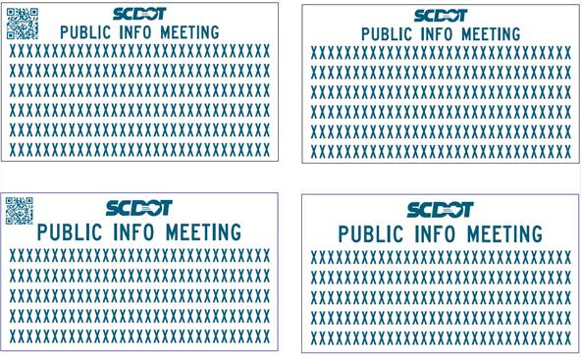

**Sign Placement**

Note: Please attach a map and/or KMZ file showing location for placement of each sign.

|  |  |
| --- | --- |
| **Action Item** | **Date** |
| Signs need to be in place by this date | 3/10/2025 |
| Signs need to remain in place through this date | 3/10/2025 |
| Signs need to be removed during this timeframe | 3/10/2025 |

**___________________________________________________________________**

**This section to be completed by Public Engagement**

**Sign Request reviewed and approved by Public Engagement**

**County:**

|  |  |  |
| --- | --- | --- |
| **Maintenance Contacts** | **Phone Number** | **Email Address** |
|  |  |  |
|  |  |  |