RD. / RTE. NO: |  | RD. / RTE. NAME: |  |  | PROJECT ID:
COUNTY: |  | PROJECT DESCRIPTION:
SUBMITTAL TYPE: |  | SUBMITTED BY: |  | RPG/DISTRICT/  CONSULTANT:
QC PERFORMED BY: |  | DATE:
QA PERFORMED BY: |  | PROJECT TYPE:
Preliminary Bridge Plans shall be submitted to and reviewed by the Structural Des Support Quality Assurance Office prior to the designer proceeding with preparation of 95% Bridge Plans. The Preliminary Bridge Plans shall be subjected to a thorough Quality Control (QC) / Quality Assurance (QA) review by the designer prior to submittal to the SCDOT Structural Design Support Office. Failure to provide proper level of review by the designer or the Engineer of Record (EOR) will be cause for rejection of the plans and submittal will be returned for proper plans preparation. Design review comments made by SCDOT on the Preliminary Bridge Plans shall be addressed and responses from EOR returned to SCDOT together with 95% Bridge Plans.
This checklist is organized by Plan sheet sequence as referenced in SCDOT Bridge Design Manual (BDM) Section 3.3.

Is a design variance required for any part of the project that does not meet the requirements of the SCDOT Design References? - See BDM Section 11.2.3 /11.2.3.2 ☐ Yes ☐ No ☐ N/A
A comprehensive list of SCDOT Design References is now available on the SCDOT website:
https://www.scdot.org/business/design-quality.aspx

Title Sheet Drawing no. 700-01, 700-02 BDM Section 6.3.1
☐ Project Layout Map - BDM Section 6.3.1.1
  - County Name – Use both county names when bridge crosses over county line
  - Project ID (verify correctness with SCDOT Project Manager)
  - Route Number followed by Local Road Name in parentheses
  - Crossing Description – Replace Bridge Over …, Construct Bridge Over … (for new location), and Widen Bridge Over… Rehabilitate Bridge Over …, etc.
☐ Project Layout Map and an arrow(s) indicating stationing direction(s), including Longitude and Latitude - BDM Section 6.3.1.5
  - Add Project Location Map using SCDOT County or City Maps. Maps are scaled to provide legible detail and provide adequate level of information for locating project site
  - Orientation of Project Layout Map matches direction of North Arrow
  - Site Location label added with line terminator ending with a circle enclosing bridge site
  - Direction of Stationing noted
☐ Index of Sheets provided - BDM Figure 6.1-1 & BDM Section 6.3.1.2
  - Sheet number indicated matches sheet number of each individual plan sheet
  - Name of each sheet matches titles located in title blocks of individual plan sheets
☐ Utility Location Note included – BDWG 700-01 & BDWG 700-02
☐ Correct Asset ID number entered in plans -LRGD and MEMO DM0420
☐ Traffic Data provided (current year, design year, % trucks) - BDM Section 6.3.1.4
☐ Correct Project Length - BDM Section 6.3.1.3. All numbers truncated to a thousandth of a mile
  - Approach slabs not included in the Net Length of Bridge
  - Net Length of Roadway is zero, unless all Road Plans and Road Quantities are included within Bridge Plans

☐ Shop Plans Submittal Box - proper contact information is provided - BDWG 700-01 & BDWG 700-02
☐ Location Box - BDM Section 6.3.1.6
  - Latitude provided
  - Longitude provided

☐ Signature Blocks (label level of submittal) - BDM Section 6.3.1.8
☐ Date of Plan Set, CADD Information, and plot stamp - BDM Section 6.3.1.9
☐ Low Volume Bridge Note added, if applicable. Verify all Selection Characteristics are met per SCDOT PCDM-11
☐ Date of Plan Set, CADD Information, and plot stamp BDM Section 6.3.1.9

General Notes Sheet Drawing no. 700-03, 700-04 BDM Section 6.3.3
☐ Updated revision block with project name, initials, date per BDWG 700-03, 700-04
☐ Updated Seismic Design Category (SDC), Analysis Method, and seismic Operational Classification (OC) based on SDS Table 3.1
  - Seismic Design Category (SDC) provided – SDS Table 3.5, BDWG 700-03.01
  - Analysis Method provided – BDWG 700-03.01
  - Operational Classification provided –Table 3.1 SDS, BDWG 700-03.01
  - PGA (FEE & SEE) provided
  - SDS (FEE & SEE) provided
  - SD1 (FEE & SEE) provided
  - Acceleration Design Response Spectrum Data Tables (FEE & SEE) completed
  - Identify how values are determined - BDWG 700-03.01

☐ Verify Seismic data included follows the Preliminary Geotechnical Engineering Report for the project
☐ Low Volume Bridge - Seismic data from BDWG 700-03.01 & Seismic design acceleration coefficient SD1 (SEE) is based on project location relative to US Route 1
☐ Verify project design per correct version of LRFD specifications – MEMO DM0220, BDWG 700-03
☐ Ensure Design Data includes appropriate Design Live Load
☐ Ensure minimum requirements for reinforcing bars are listed as per AASHTO M31, Type W (ASTM A706 Grade 60) see BDM Section 15.2.2
☐ Ensure minimum grades and types of structural steel are met per BDM Section 16.2
☐ Ensure all bolts are minimum ASTM F3125 (Type 1) galvanized or ASTM F3125 (Type 3) weathering steel
☐ Final Surface Finish selected

Roadway Typical Section Sheet BDM Section 6.3.5
☐ Ensure Roadway approaches on both sides of the bridge shown on Bridge Plan and Profile sheet match Typical Roadway Section - BDM Section 6.3.5
☐ Ensure total travelway width and shoulders match approaches on both sides of the bridge - see BDMFigure12.6-1
☐ Uniform cross-slope for normal crown is 2%
☐ If the proposed bridge is over a roadway, include a typical section of the lower roadway
☐ Roadway Typical Section Sheet labeled “For Information Only”

Roadway Plan and Profile Sheet BDM Section 6.3.6
☐ Ensure Roadway sheets included in the Bridge Plans match the most current revision of the roadway plans
☐ Roadway Plan and Profile Sheet labeled “For Information Only”
☐ Bridge end drainage shown
☐ Applicable thrie-beam connector note(s)
☐ New bridge construction drawing and note included
☐ Grades, elevations, end drainage, riprap, MSE wall, concrete slope protection at end bents, lengths and guardrail/ barrier transition type match the bridge plans

Stages of Construction Sheet Yes No N/A BDM Section 6.3.7
☐ Show existing conditions along with existing structures to be impacted
☐ Areas of the existing structure that will be removed during each stage
☐ New portions of the structure that will be constructed during each stage
☐ Show where traffic will be accommodated
☐ Locations of traffic control devices, including temporary concrete barriers
  - Reference appropriate roadway standard drawings for installation
  - Note that traffic control devices are roadway items
☐ Verify if additional deck design is needed in order to support temporary barriers placed on deck overhangs
☐ Note if traffic control items are roadway pay items
☐ Show dimensions necessary for construction
  - Stage widths
  - Traffic direction
  - Lane widths
  - Shoulder/median widths
  - Distance from edge of stage to centerline (CL) new structure/roadway
  - Distance from edge of new structure to edge of existing structure
  - Distance from CL new structure/roadway to CL existing structure/roadway
  - Clear distance between structures
  - Distance from temporary barrier to edge of construction
  - Roadway widths
  - Slab out-to-out width
  - Lane, shoulder, median widths
☐ Notes describing each stage of construction

Bridge Plan and Profile Sheet Drawing no. 700-06 BDM Section 6.3.8
Plan View BDM Section 6.3.8.1
☐ Show the largest engineering scale practical to fit on the sheet. Use multiple sheets if necessary
☐ Show existing bridge with light dashed line. Include a note on its size, material, removal and disposition per Standard Specifications
☐ Show new bridge and approach slabs using solid lines
☐ Label beginning & end of bridge
☐ Show centerlines for roadway construction, survey centerline across the structure including centerlines of roadways or railroads underneath the structure
☐ Tangent centerlines should be labeled with their bearings in the style of Northing - Easting, and degree of curve
☐ Where the roadway is on a horizontal curve show clear horizontal curve data. Label the applicable PC and PT for the roadway. Ensure horizontal curve data matches the roadway sheets
☐ Station marks increasing left to right, at 100-ft increments at top of sheet
☐ Show tie equality stationing at the intersection of design centerline and crossroad and/or railroad centerlines
☐ Show matchline stationing where the structure is drawn on two or more sheets
☐ Dimension the overall roadway width across the structure. Ensure it is consistent with the Roadway Typical Section
☐ Dimension the width from the construction centerline to each edge of the roadway
☐ Dimension the railing wall widths and slab extension behind the railing wall
☐ Dimension the travel lane, shoulder, and median widths prior to and beyond the structure
☐ Dimension the sidewalk widths
☐ Dimension the minimum horizontal clearances for roadways and railroads crossed over - BDM Section 12.6
☐ Dimension the horizontal distance between construction centerlines for dual structures
☐ Dimension the offset width between the roadway construction centerline and the structure centerline
☐ Dimension the width of each stage, for staged projects. Ensure it matches the Stage of Construction sheets
☐ Drains:
  - Show spacing of deck drains and to which side(s) they apply. If not required, indicate this in a note. Deck drains are recommended if there are no environmental restrictions
  - A drainage inlet must always be located at the low point of a sag vertical curve - BDM Section 18.2.4
  - Flanking inlets placed 5 feet on either side of the low point of a sag vertical curve - BDM Section 18.2.4
  - Drains should not be located within 5’ from edge of substructure - BDM Section 18.2.5.4.1
  - Scupper outlets are not allowed over railroad right-of-way - BDM Section 18.2.5.4
☐ Show end drainage or reference roadway plans
☐ Show skew angle between the construction centerline, or long chord on curved bridges, and the centerline at one or more of the bents even when 90 degrees
☐ If the roadway is superelevated across the structure, provide a detail showing the cross section view of the superelevated section
☐ If the superelevation transitions on the structure, provide a detail showing the method of superelevation
☐ Route number, Railroad (R.R.) name, traffic direction to nearest town if applicable
☐ Stream crossing name and direction of flow if applicable
☐ Traffic directions for crossing highway
☐ North arrow
☐ Curb and gutter
☐ Show and label Guard rail
☐ Offset to detour bridge

☐ Benchmark data and elevations show minimum two benchmarks, indicate location by station, and distance left or right from construction center line, note the type of benchmarks, including the elevation of the benchmarks rounded up to the nearest hundredth of a foot –BDM 6.3.8.3
☐ Specify location of expansion or deflection joints
☐ Toe of fills and/or top of cuts
☐ Limits of slope protection or riprap
☐ Temporary shoring location if applicable
☐ Show retaining walls if applicable
☐ Structure-mounted signs or luminaires
☐ Show boring locations and verify consistency with boring log sheets
☐ All utilities, pipes, power lines, etc. and label owners
☐ For bridge widening comply with BDM Chapter 23
☐ Label point of minimum vertical clearance (“PMVC”)
☐ Show legend list used on the sheet

Railroads (R.R.) - BDM Section 22
☐ Show horizontal alignment of the railroad crossed over
☐ Distance between track centers = 15 ft. minimum
☐ Minimum horizontal clearance from the centerline of the track = 25 ft. - BDM Section 22.2.3.2
☐ Edges of the footing should not be closer than 15.0 ft. from the centerline of the track - BDM Section 22.2.3.2
☐ For lateral clearance on curved and superelevated tracks see BDM Chapter 22 and Figure 22.2-4
☐ Existing horizontal and vertical clearances should be maintained for widening projects. Clearances for reconstruction work or for alteration of existing tracks are dependent on existing physical conditions and, where reasonably practical, should be improved to meet the requirements for new construction - BDM Section 22.2.3.7
☐ If bents supporting bridges over railways are within a clear distance of 25.0 ft. or less from the centerline of a railroad track, bents shall be of heavy construction or shall be protected by a 2.5ft thick reinforced concrete crash wall to limit damage by the redirection and deflection of railroad equipment - BDM Section 22.2.3.5
☐ Construction casing shall be specified for drilled shafts that are located within 30 ft. of the centerline of an existing railroad track. For drilled shaft locations greater than 30 ft. from the centerline of a track, consideration shall be given to requiring construction casing - BDM Section 22.2.7
☐ Concrete slope protection pavement should be provided where practical- BDM Section 22.2.3.6
☐ Dimension ROW limits for railroads
☐ Include table with the elevation for each rail at each railroad station along with date of the survey
☐ Stations and Elevations of R.R. rails, distances center to center tracks, label present and future track
☐ Show the distance to the nearest railroad milepost from the intersection of the centerline track and centerline of the bridge
☐ Note to contractor in regards of verifying top-of-rail and existing alignment
☐ Comply with BDM Chapter 22 and MEMO DM0307 for design and construction criteria
☐ Temporary horizontal construction clearances shall be noted on the plans as a minimum of 13.0 ft. for tangent tracks and 14.0 ft. for curved tracks measured from the centerline of track. Temporary vertical construction clearance shall be noted as 22.0 ft. above the top of high rail. The railroad company may request increased temporary clearances after review of the preliminary plans - BDM Section 22.2.3.2
☐ A protective fence will be provided if requested by the railroad company - BDM Section 22.2.6
☐ For CSX overhead bridges, refer to "CSX Criteria for Overhead Bridges"

Profile View BDM Section 6.3.8.2
☐ Avoid locating a sag vertical curve low point on the bridge or approach slab see BDM Section 18.2.1.2
☐ Label the Profile view with the appropriate name according to what is representing “SECTION ALONG …”
☐ Note the stationing rounded up to the second decimal place
☐ Note finish grade elevations rounded up to one thousandth of a foot at Begin/End Bridge, CL Bents, Begin /End Approach slab
☐ All stations shown at 100-ft increments, along the bottom of the profile view (e.g., 807 + 00, 808 + 00) and the appropriate in-between stations (e.g., +10, +20, +30 or +20, +40, +60), depending on the scale
☐ Show superstructure type, deck, piles, shafts, footings, bent caps, approach slabs at beginning /end bridge
☐ Consecutively number each bent by increasing stations matching the plan view. Also, provide a label to indicate that these are the bent numbers (i.e., BENT NO. →).
☐ Note the stationing of PVI, PVC, and/or PVT if applicable
☐ Show vertical curve data, including, length of vertical curve, forward and back tangent grades in percent, PVI station and elevation. Verify vertical curve data match the roadway plans
☐ If open drainage is used, minimum longitudinal deck gradient = 0.3% per BDM Section 18.2.1
☐ Show the existing ground line and finished grade line profile at the construction centerline. Include left and right of the centerline profiles with dashed lines
☐ Dimension minimum vertical clearance for roadways per BDM Section 12.6 and railroads passing under the structure.
☐ Minimum vertical clearance shall be 23.0 ft. - BDM Section 22.2.3.2
☐ Show 100-year and 500-year scour lines
☐ Water surface elevation at the time of survey
☐ Show the 100-year, 50-year, 25-year, and highest recorded high-water elevations as applicable for the project
☐ Hydraulic data, drainage area, design year flow, elevation, overtopping, backwater elevation and water fluctuation note if applicable
☐ Ensure Hydraulic data matches the most current data roadway plans
☐ Ensure hydraulic freeboard requirements for the project are met
☐ Label each bent and show stationing of each bent rounded up to the second decimal place
☐ Show elevations at centerline of each bent rounded up to a one thousandth of a foot
☐ Low chord elevation
☐ Dimension out-to-out horizontal distance of the overall bridge length
☐ Dimension approach slabs
☐ Dimension continuous spans and each span length
☐ Bent numbers if multiple span structure
☐ Label the superstructure type in the overall bridge length dimension line
☐ Label type of bearing at each bent (fixed, integral, etc.)
☐ Add construction notes applicable to the drawing
☐ Label slope rate and slope protection type
☐ If roadway crosses underneath the bridge: If bents within 30 feet from edge of travel lane comply with MEMO DM0213 and BDM Section 20.2.3.1 and BDM Figure 20.2-2
☐ Show embankment at least 1 ft. above the bottom of the end bent cap
☐ Detail the wing walls to allow for a minimum berm width of 2 ft. measured perpendicular to the bent cap
☐ Show toe of riprap embedded 1 ft. below existing ground
☐ Show all utilities that may interfere with bridge construction (or note if identified on Roadway plans)
☐ Ensure bridge span selection meet the criteria of Table 1 below or per design variance approved by SCDOT.

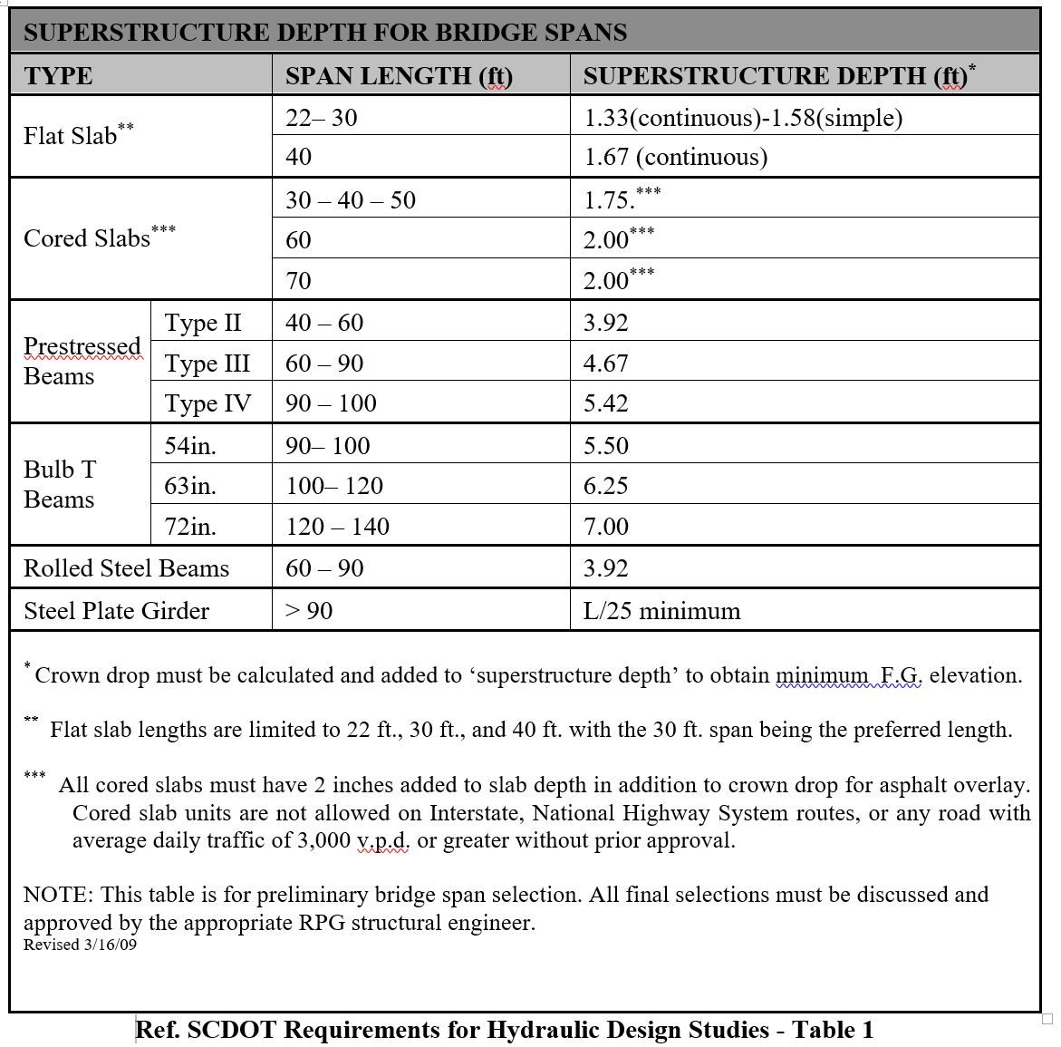

☐ All spans shall meet AASHTO LRFD Table 2.5.2.6.3-1 -- Traditional Minimum Depths for Constant Depth Superstructures
☐ For bridge widening comply with BDM Chapter 23
☐ Excavation cross-hatched & label “See Road Plans”

Railroads (R.R.):
☐ Railroad cross sections should be shown at 25-ft intervals for 100-ft on each side of the centerline of the bridge – BDM 3.3.2.10
☐ The new end fill slopes should be plotted on the cross sections
☐ Clearances between the toe of slope and railroad tracks shown if applicable
☐ Reference MEMO DM0213 for interior bents within 25 feet to 50 feet of CL of railroad tracks

☐ Vertical clearance shall be set between a minimum of 23 ft. and a maximum of 23.4 ft. Reference BDM 22.2.3.2.3
☐ Comply with SCDOT BDM Chapter 22 and DM0307 for design and construction criteria

Boring Logs Sheet BDM Section 6.3.9
☐ Show Boring Logs
☐ Note “For Information Only” included
☐ Boring log locations presented in a format of "station and offset"

Foundation Layout Sheet BDM Section 6.3.10

☐ Show stationing marks increasing left to right, at 100-ft increments at top of sheet
☐ Dimension overall structure’s length
☐ Label bent number
☐ Call out center line of piles or shafts
☐ Note the size of the piles or diameters of drilled shafts
☐ Stationing rounded up to the second decimal place shown where construction centerline intersects the centerline of each bent and begin/end bridge
☐ Show construction centerline, bridge center line, alignment data and work points
☐ Location of existing foundations drawn in light dashed lines
☐ Note and dimension any existing substructure
☐ Show north arrow
☐ Show skew angle of all bents
☐ Show Long Chord Layout including skew angles and offsets for curves at critical points - BDM Section 6.3.10
☐ Dimension length of span and label it
☐ Show stages of construction if applicable
☐ Add geotechnical notes if not included on other sheets
☐ Show location of temporary shoring wall
☐ Label index piles
☐ Show legend if applicable
Bent Sheets (End Bent / Interior Bent) BDM Section 6.3.11
Plan view (typical bents)* BDM Section 6.3.11.2
End/Interior*
☐ ☐ Select scale that allows both the plan and elevation view of a bent to fit on one sheet and clearly show the reinforcing details
☐ ☐ Note direction of stationing
☐ ☐ Centerline of construction, survey or bridge centerline noted
☐ ☐ Dimension overall length of the bent
☐ ☐ Dimension distances between the outside edges of the bent to centerline of construction, survey or bridge centerline
☐ ☐ Dimension bent width
☐ ☐ Dimension bearing and bent centerline
☐ ☐ Dimension distances to centerlines dowels, bearings etc.
☐ ☐ Dimension girder/beam spacing including distance to and from first/last girder to end of bent
☐ ☐ Show distances from centerline to staged construction joint if applicable
☐ ☐ Skew angle shown
☐ ☐ Show beam numbers if applicable
☐ ☐ Show beam seat location, size and anchor bolt information
☐ ☐ Wing Walls length and width shown
☐ ☐ Show shear keys if applicable
☐ ☐ Type and thickness of expansion joint material if applicable

Elevation View (typical bents) or Bridge Typical Section BDM Section 3.3.2.7 & 6.3.11.3 & 6.3.13.4.1
☐ Centerline of construction, survey or bridge centerline noted
☐ Dimension overall length of the bent
☐ Dimension distances between the outside edges of the bent to centerline of construction, survey or bridge centerline
and to wing walls
☐ Dimension out-to-out superstructure width
☐ Dimension overall superstructure thickness
☐ Show pile/shafts/column type, size and spacing
☐ Dimension centerline (CL) of first/last pile to end of bent and from CL of pile to construction CL
☐ Label superstructure type
☐ Number the Piles/Drilled Shaft or Columns and show their size
☐ Dimension widths between the construction centerline to the gutter line
☐ Barrier width and distance between the barrier and the edge of the deck
☐ Sidewalk width if applicable
☐ Median width if applicable
☐ Direction of cross slope in percent
☐ Finished grade
☐ Drip groove shown
☐ Deck drains shown if applicable
☐ Lane and shoulder width shown. Ensure they match the latest Roadway sheets
☐ Dimension the thickness of the slab
☐ Dimension overall superstructure depth
☐ Height of barrier/ parapet wall
☐ Girders/beams type and cross bracing if applicable
☐ Miscellaneous
☐ Location of utilities attached to the structure
☐ Dimension widths of stages of construction if applicable
☐ High and low sides of superelevated sections
☐ Construction joints/ closure pour shown
☐ Gutter line
☐ Special notes
☐ Legend if applicable
☐ Label location of construction Joints, widths, and type of expansion material
☐ Construction notes☐ Span length guidelines per SCDOT BDM Figure 12.3-1
Structure Type | Span Length Ranges (feet)
 | ≤ 40 | > 40 to 100 | > 100
Prestressed Concrete Girders |  | X
Flat Slabs | X
Steel Welded Plate Girders |  | X | X
Steel Rolled Beams |  | X
Cored Slabs | X | X

☐ Ensure minimum depth for single superstructure spans is met per AASHTO LRFD Table 2.5.2.6.3-1
☐ Deck overhang should be less than 50% of the average girder spacing or meet the limitations of BDM Figure 12.2-1 below, whichever is less governs. Structural steel plate girders - the web depth shall be used as the depth of beam.
☐ For chorded girders, the overhang at any point shall not exceed 50% of the average girder spacing. See BDM Section 12.2.5.5

Type of Beam | Depth of Beam¹ | Maximum Deck Overhang
Prestressed Concrete | < 54” | 42”
 | 54” – 63” | 48”
 | > 63” | 54”
Structural  Steel | < 36” | Depth of Beam
 | 36” – 48” | 42”
 | > 48” | 45”
1 - structural steel girders, depth of beam = depth of web
    - Minimum overhang = greater of 12” beyond edge of top flange and 2’-3” beyond centerline of girder - BDM Section 12.2.5.5

Section through bent cap (typical bents) BDM Section 3.3.2.6
☐ Show all anticipated cap dimensions
☐ Show Begin/End Bridge, CL Bents, Begin/End Approach slab, joints
☐ Dimension CL of beam seat to the outside edge of bent cap
☐ Label superstructure type
☐ Dimension typical length of pile embedment into the bent cap
☐ Show top of embankment fill as per BDM Fig. 20.2-2 and location of riprap if applicable
☐ The top of the bent cap - minimum of 12 in above the surrounding grade (including any rip rap placed on earth berm).
☐ The bottom of the bent cap detailed a minimum of 12 in below the earthen berm -BDM Section 20.2.3. Account for rip-rap thickness resting on top of earthen berm when determining cap depth – RDWG 804-105-00
☐ Maintain a minimum berm width of 2 ft. measured perpendicular to the bent cap

Existing Bridge Plans Sheets Ref: Online Plans Library & BDM Section 6.3.19
☐ Existing Bridge Plans included
☐ Note “For Information Only” included on each sheet
☐ New sheet numbers and Project ID added at tops of sheets

