
DRILLED SHAFT LOG (REV 06-03-02)
Project Name |  |  |  |  |  |  |  |  |  |  |  |  |  |  |  |  |  |  |  | Page |  | 1 |  |  | of |  |  | 6
File No. |  |  |  |  |  |  |  |  |  |  |  |  |  |  |  |  |  |  |  | Bent No.
Contractor |  |  |  |  |  |  |  |  |  |  |  |  |  |  |  |  |  |  |  | Shaft No.
Completed By Contractor |  |  |  |  |  |  | DS Foreman - |  |  |  |  |  |  | Date |  |  | / / |  |  | Station
Reviewed By SCDOT |  |  |  |  |  |  | Inspector - |  |  |  |  |  |  | Date |  |  | / / |  |  | Offset
Construction Temporary
 | Date Cased |  |  |  |  |  |  |  |  |  | Casing Type:
 | Date Opened |  |  |  |  |  |  |  |  |  | Casing Dimension (OD):
 | Date Poured |  |  |  |  |  |  |  |  |  | Bottom of Casing Elevation (FT)
 |  |  |  |  |  |  |  |  |  | Top of Casing Elevation (FT)
 |  | Elevation (ft) |  |  |  |  |  |  |  | Diameter of Rock Socket (IN)
 |  |  |  |  |  |  |  |  |  | Diameter of Shaft (IN)
 |  |  |  |  |  |  |  |  |  | Mud-line/Ground Surface Elevation (FT)
 |  |  |  |  |  |  |  |  |  | Wet & Dry Shaft Length (FT)
 |  |  |  |  |  |  |  |  |  | Rock Socket Length (FT)
 |  |  |  |  |  |  |  |  |  | Top of Shaft Elevation (FT)
 |  |  |  |  |  |  |  |  |  | Tip Elevation (FT)
 |  |  |  |  |  |  |  |  |  | Constructed Shaft Length (FT)
 |  |  |  |  |  |  |  |  |  | Testing/Other:
 |  |  |  |  |  |  |  |  |  | Volume of Concrete: |  |  |  |  |  |  |  |  | Theoretical (VT) CY
 |  |  |  |  |  |  |  |  |  | OP = VP-VT = |  |  |  |  | UP = VT - VP= |  |  |  | Actual (VP) CY
 |  |  |  |  |  |  |  |  |  | Reinforcement Cage Installed: |  |  |  |  |  |  |  |  | Type
 |  |  |  |  |  |  |  |  |  | Duration of Pour (min)
 |  |  |  |  |  |  |  |  |  | Legend
 |  |  |  |  |  |  |  |  |  | TOC |  |  | Top of Casing |  |  |  |  |  |  |  |  |  |  | Sand
 |  |  |  |  |  |  |  |  |  | TOG |  |  | Top of Ground
 |  |  |  |  |  |  |  |  |  | TOS |  |  | Top of Shaft |  |  |  |  |  |  |  |  |  |  | Silt
 |  |  |  |  |  |  |  |  |  | TOR |  |  | Top of Rock
 |  |  |  |  |  |  |  |  |  | BOC |  |  | Bottom of Casing |  |  |  |  |  |  |  |  |  |  | Clay
 |  |  |  |  |  |  |  |  |  | BOS |  |  | Bottom of Shaft
 |  |  |  |  |  |  |  |  |  | BOR Bottom of Rock |  |  |  |  |  |  |  |  |  |  |  |  |  | Rock
 |  |  |  |  |  |  |  |  |  | Water Level
 |  |  |  |  |  |  |  |  |  | Completed by
 |  |  |  |  |  |  |  |  |  | Contractor |  |  |  |  |  | DS Foreman/Engineer
 |  |  |  |  |  |  |  |  |  | Reviewed by
 |  |  |  |  |  |  |  |  |  | SCDOT |  |  |  |  |  | Inspector/Engineer
 |  |  |  |  |  |  |  |  |  | Notes:
 |  |  |  |  |  |  |  |  |  | Shaft location variance at top:

HOW TO COMPLETE THE
DRILLED SHAFT LOG

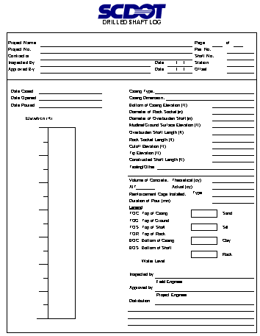

1

Fill in every blank on the form. If it does not apply put an “N/A” or a long dash.

Use pencil – but never erase. If you need to change something, strike a single line through the item and insert the correct information above it. If there is insufficient room to make a note, footnote the item and go to the bottom of the page, or use a separate page.

2

3

4

5

- Heading: - Fill in before drilling starts.
- Be sure to print your name and the start date of drilling.
- The Geotechnical Engineer will sign approval line.
2. Shaft Data: - Fill in appropriate dates, elevations, and diameters.

3. Concrete Data: Record data from the Concrete Volumes form.

4. Construct Shaft Illustration using the symbols provided.

5. Fill in “Inspected by” and “Distribution”.

DRILLED SHAFT EXCAVATION LOG (REV 06-03-02)
Project Name |  |  |  |  |  |  |  |  |  |  |  |  |  |  |  |  |  |  | Page | 2 |  | of |  | 6
File No. |  |  |  |  |  |  |  |  |  |  |  |  |  |  |  |  |  |  | Bent No.
Contractor |  |  |  |  |  |  |  |  |  |  |  |  |  |  |  |  |  |  | Shaft No.
Completed By Contractor |  |  |  |  |  |  |  | DS Foreman - |  |  |  |  |  |  |  | Date | / / |  | Station
Reviewed By SCDOT |  |  |  |  |  |  |  | Inspector - |  |  |  |  |  |  |  | Date | / / |  | Offset
Note: Preaugering not allowed when using construction casing.
Casing Information |  |  |  |  |  |  |  |  |  |  |  |  |  |  |  |  |  | Soil Auger Diam.
 | ID |  | OD |  |  | Top Elev. |  |  |  | Length |  |  |  | Bot. Elev. |  |  |  | Rock Core Diam.
 |  |  |  |  |  |  |  |  |  |  |  |  |  |  |  |  |  | Ground Surface Elev.
 |  |  |  |  |  |  |  |  |  |  |  |  |  |  |  |  |  | Water Table Elev.
 |  |  |  |  |  |  |  |  |  |  |  |  |  |  |  |  |  | Reference Elev.
 |  |  |  |  |  |  |  |  |  |  |  |  |  |  |  |  |  | Drilling Mud
 | Notes
Depth  ( ) |  |  |  | Elev.  ( ) |  |  | Time |  |  |  |  | Soil Description and Notes
 |  |  |  |  |  |  |  |  |  |  | In
 |  |  |  |  |  |  |  |  |  |  | Out
 |  |  |  |  |  |  |  |  |  |  | In
 |  |  |  |  |  |  |  |  |  |  | Out
 |  |  |  |  |  |  |  |  |  |  | In
 |  |  |  |  |  |  |  |  |  |  | Out
 |  |  |  |  |  |  |  |  |  |  | In
 |  |  |  |  |  |  |  |  |  |  | Out
 |  |  |  |  |  |  |  |  |  |  | In
 |  |  |  |  |  |  |  |  |  |  | Out
 |  |  |  |  |  |  |  |  |  |  | In
 |  |  |  |  |  |  |  |  |  |  | Out
 |  |  |  |  |  |  |  |  |  |  | In
 |  |  |  |  |  |  |  |  |  |  | Out
 |  |  |  |  |  |  |  |  |  |  | In
 |  |  |  |  |  |  |  |  |  |  | Out
 |  |  |  |  |  |  |  |  |  |  | In
 |  |  |  |  |  |  |  |  |  |  | Out

HOW TO COMPLETE THE
DRILLED SHAFT EXCAVATION LOG

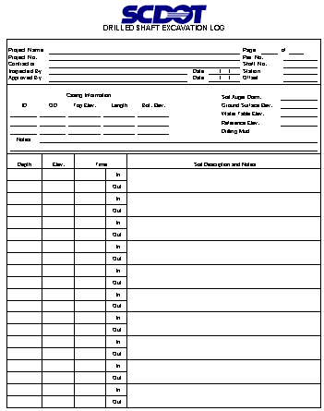
1

2

4

6

5

3

Fill in every blank on the form. If it does not apply put an “N/A” or a long dash.

Use pencil – but never erase. If you need to change something, strike a single line through the item and insert the correct information above it. If there is insufficient room to make a note, footnote the item and go to the bottom of the page, or use a separate page.

1. | Heading: | -Fill in before drilling starts.
 |  | -Be sure to print your name and the start date for drilling.
 |  | -The Geotechnical Engineer will sign approval line.
2. | Casing: | -Measure Length (L) in the field.
 |  | -Surveyor provides Top of Casing elevation (TE).
 |  | -Compute bottom elevation(BE): TE-L=BE
3. | Site Data | -Soil Auger diameter – measure and record in inches.
 |  | -Ground surface elev. – provided by surveyor.
 |  | -Water table elev. – measure w/tape in hole before slurry is introduced (if applicable).
 |  | -Water table may need to be estimated from seepage in dry hole method.
 |  | -Reference Elevation – provided by surveyor.
 |  | -Drill mud – If used, complete the “Slurry Inspection Log”; compare to Installation Plan
4. | Depth/Elevation: | Depth (D) can be measured by:
 |  | 1) Contractor has kelly bar marked (spot checking only)
 |  | 2) Weighted tape (for accurate measurements)
 |  | Reference elevation is always known; i.e., template, top of casing, or top of ground.
 |  | Elevation (E) – compute TE-D=E
 |  | Enter Depth/Elev. For EVERY change in the soil/rock condition.
5. | Time: | May use military or 24 hour clock. Be consistent and correct! Remember that shaft
 |  | drilling can occur over several days, so be sure to mark date changes.
6. | Material: | Use this form to record all activity during shaft excavation. Label all major soil strata.

HOW TO COMPLETE THE
SLURRY INSPECTION LOG
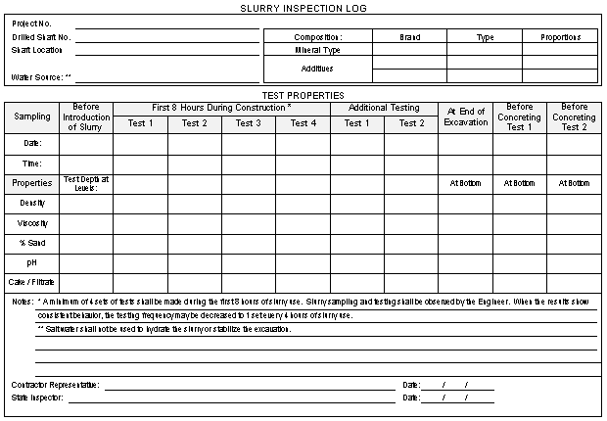
1

2

4

5

3

Fill in every blank on the form. If it does not apply put an “N/A” or a long dash.

Use pencil – but never erase. If you need to change something, strike a single line through the item and insert the correct information above it. If there is insufficient room to make a note, footnote the item and go to the bottom of the page, or use a separate page.
1. Heading: - Fill in before drilling starts.
- The Project Resident Engineer will sign approval line.

2. Slurry Data: - Fill in appropriate brands, types, and proportion.

3. Test Data: - Record test data as the testing Inspector performs the tests.
- Note the depth at which the samples were obtained.
- Make sure that a minimum of 4 tests are performed within
the first 8 hours of slurry use.

4. Notes: Record any unusual events or results.

5. Fill in “Contractor Representative” and “State Inspector”.

DRILLED SHAFT INSPECTION LOG (REV 06-03-02)
Project Name |  |  |  |  |  |  |  |  |  |  |  |  |  |  |  |  |  |  |  |  | Page |  |  | 4 |  | of |  |  | 6
File No. |  |  |  |  |  |  |  |  |  |  |  |  |  |  |  |  |  |  |  |  | Bent No.
Contractor |  |  |  |  |  |  |  |  |  |  |  |  |  |  |  |  |  |  |  |  | Shaft No.
Completed By Contractor |  |  |  |  | DS Foreman - |  |  |  |  |  |  |  |  |  | Date |  |  |  |  |  | Station
Reviewed By SCDOT |  |  |  |  | Inspector - |  |  |  |  |  |  |  |  |  | Date |  |  |  |  |  | Offset
 | Type of Drilling Fluid |  |  |  |  |  |  |  |  |  |  |  |  | Shaft Plumbness Check/4'
 | DS Location Variance at Top |  |  |  |  |  |  |  |  |  |  |  |  | Rebar Cage: |  | Proper # Vert. Bars
 | Bottom Cleanout Method |  |  |  |  |  |  |  |  |  |  |  |  |  |  | Proper # Horiz. Bars
 | Time/Date Final Cleanout |  |  |  |  |  |  |  |  |  |  |  |  |  |  | Side Spacers
 | Shaft Bottom Elev. |  |  |  |  |  |  |  |  |  |  |  |  |  |  | Bottom Spacers
 | Est. Shaft Bottom Dia. |  |  |  |  |  |  |  |  |  |  |  |  |  |  | Ties & Connections
 |  |  |  |  |  |  |  |  |  |  |  | * Based on Compass Direction
 | Inspected By: |  |  |  |  |  |  | Visual____ Sounding ____ |  |  |  |  | N *
 | Time Test Started |  |  |  |  |  |  |  |  |  |  | Test just prior to placing Rebar cage (inches)
 | Time Test Finished |  |  |  |  |  |  |  |  |  |  | Test just prior to placing concrete (inches)
 | Time Test Started |  |  |  |  |  |  |  |  |  |  | * Direction
 | Time Test Finished ____________
 | W * |  |  |  |  |  |  |  |  |  |  | E *
 | Note: 50% of base shall have < 1/2 Inch of sediment.
 | No area of shaft bottom shall be more than 1 1/2 Inches.
 | Notes |  |  |  |  |  |  |  |  |  |  |  |  |  |  |  | Comments/Recommendations
 |  |  |  |  |  |  |  |  |  |  |  |  | S *
 | Results: |  |  | Satisfactory |  |  |  |  | DS Foreman
 |  |  |  | Unsatisfactory |  |  |  |  | SCDOT Inspector |  |  |  |  |  |  |  |  |  | Time |  |  |  |  |  | Date
NOTE: Specification Tolerances - Location Variance at Top = 3 inches Max. Vertical (Plumbness) = 1 inch per 4 Ft. Max.

HOW TO COMPLETE THE
DRILLED SHAFT INSPECTION LOG

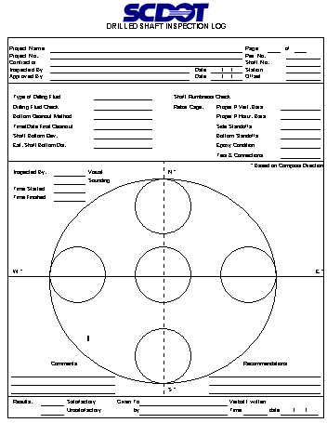
1

2

4

5

3

Fill in every blank on the form. If it does not apply put an “N/A” or a long dash.

Use pencil – but never erase. If you need to change something, strike a single line through the item and insert the correct information above it. If there is insufficient room to make a note, footnote the item and go to the bottom of the page, or use a separate page.

1. | Heading: | -Fill in before drilling starts.
 |  | -Be sure to print your name and the start date of drilling.
 |  | -The Project Resident Engineer or designated representative will sign approval line.
2. | Shaft Status: | Drill Fluid Check – Responsibility of Contractor. Record density check performed by Contractor or Inspector.
 |  | Type of Drill Fluid – record
 |  | a) | Natural
 |  | b) | Mineral (commercial)
 |  | c) | Plain water
 |  | Remember: Polymer slurry not allowed
-Bottom Cleanout Method: Observe and record equipment type (i.e., cleanout bucket,
air lift, submersible pump, etc.). Must match Installation Plan.
-Time/Date Final Cleanout: Record when last cleanout performed prior to rebar cage
placement.
 |  | -Shaft Bottom Elevation – Use weighted tape to measure; record.
 |  | -Estimate Shaft Bottom Diameter – record auger diameter.
3. | Cage Check: | -Reinforcing cage usually checked by others.
-Proper number of Vertical bars – count and record # of vertical bars in hole; compare
to plan.
 |  | -Epoxy – you should never see coated rebar
4. | Shaft Cleaniness: | – check procedure being used, record
1) Using S.I.D., visually inspect the shaft bottom in each of a minimum of 5
locations as shown on form.
2) Using a weighted tape, sound the shaft in each of a minimum of 5 locations as
shown on form. “Feel” for hard bottom – it translates to clean hole.
Remember specifications.
5. | Record Results:

DRILLED SHAFT CONCRETE PLACEMENT LOG (REV 06-03-02)
Project Name |  |  |  |  |  |  |  |  |  |  |  |  |  |  |  |  |  |  |  |  |  |  |  |  |  |  |  |  |  |  |  |  |  |  |  |  |  | Page |  |  |  | 5 | of |  |  |  | 6
File No. |  |  |  |  |  |  |  |  |  |  |  |  |  |  |  |  |  |  |  |  |  |  |  |  |  |  |  |  |  |  |  |  |  |  |  |  |  | Bent No.
Contractor |  |  |  |  |  |  |  |  |  |  |  |  |  |  |  |  |  |  |  |  |  |  |  |  |  |  |  |  |  |  |  |  |  |  |  |  |  | Shaft No.
Completed By Contractor |  |  |  |  |  |  |  |  |  | DS Foreman - |  |  |  |  |  |  |  |  |  |  |  |  |  |  | Date |  |  |  |  |  |  |  |  |  |  |  |  | Station
Reviewed By SCDOT |  |  |  |  |  |  |  |  |  | Inspector - |  |  |  |  |  |  |  |  |  |  |  |  |  |  | Date |  |  |  |  |  |  |  |  |  |  |  |  | Offset
Placement Method |  |  |  |  |  |  |  |  |  | Tremie |  |  |  |  |  | Volume in Pump Truck |  |  |  |  |  |  |  |  |  |  |  |  |  | # |  |  |  |  |  | ID |  |  |  |  | Length |  |  |  |  |  |  | Volume
 |  |  |  |  |  |  |  |  |  | Pumped |  |  |  |  |  | Pump Truck Lines
De-airing Method |  |  |  |  |  |  |  |  |  | Relief Valve |  |  |  |  |  | Pump Truck
 |  |  |  |  |  |  |  |  |  | Plug
 |  |  |  |  |  |  |  |  |  | Cap
 |  |  |  |  |  |  |  |  |  |  |  |  |  |  |  | Total Volume in Lines + Pump Truck |  |  |  |  |  |  |  |  |  |  |  |  |  |  |  |  |  |  |  |  |  |  |  |  | Σ |  |  | =
Reference Elev.
Shaft Top Elev. |  |  |  |  |  |  |  |  |  |  |  |  | Time First Truck Batched:
Top of Rock Elev. |  |  |  |  |  |  |  |  |  |  |  |  |  |  |  | Depth of Water Per Hr. Inside Shaft (Dry Hole Check)
Shaft Bottom Elev. |  |  |  |  |  |  |  |  |  |  |  |  |  |  |  | Rebar Cage Top Elev. |  |  |  |  |  |  |  | At Start - |  |  |  |  |  |  |  |  |  |  |  |  | At Finish
Truck  No. |  |  |  | Concrete  Volume |  |  |  |  | Arrival  Time |  |  |  |  | Start  Time |  |  |  |  | Finish  Time |  |  |  | Tremie  Depth |  |  |  |  | Depth To  Concrete |  |  |  |  |  | Notes
 |  |  |  |  | Concrete Volume Delivered |  |  |  |  |  |  |  |  |  |  |  |  |  |  |  |  | Total Placement Time (Temp. Casing Removed)
YES NO
 |  |  |  |  |  |  | OD |  |  |  |  | Top Elev. |  |  |  |  |  | Bot. Elev. |  |  | Start |  |  |  |  |  | Finish |  |  |  |  |  | Rebar Cage Centered*
T Casing Removal** |  |  |  |  |  |  |  |  |  |  |  |  |  |  |  |  |  |  |  |  |  |  |  |  |  |  |  |  |  |  |  |  | Rebar Cage Re-centered
Notes |  |  | * If no, then re-center rebar cage. ** If unable to remove temporary casing, then call Bridge Construction Office.

HOW TO COMPLETE THE
DRILLED SHAFT CONCRETE PLACEMENT LOG
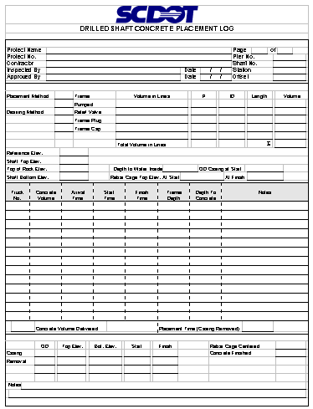
1

2

4

5

3

6

7

8

9

Fill in every blank on the form. If it does not apply put an “N/A” or a long dash.

Use pencil – but never erase. If you need to change something, strike a single line through the item and insert the correct information above it. If there is insufficient room to make a note, footnote the item and go to the bottom of the page, or use a separate page.

1. | Heading: |  | -Fill in before drilling starts.
 |  |  | -Be sure to print your name and the start date of drilling.
 |  |  | -The Project Resident Engineer or designated representative will sign approval line.
2. | Indicate correct “Placement” and “Deairing” method.
3. | Compute and fill in Concrete Volumes: V = (πd² /4) x L
4. | Fill in as much as possible prior to pour.
5. | Record Truck number and amount of concrete.
6. | Time: |  | -May be military or standard clock. Be consistent and correct.  Watch for date changes on late night pours.
7. | Depths: |  | -Tremie embedment may be measured by markings on the tremie. Depth to  concrete may be measured by weighted tape.
8. | Notes: |  | Record any unusual events or items.
9. | Casing/Rebar Data: |  | -The rebar cage fabrication will normally be performed on-site. Observe the lifting  to make sure deformation or damage does not occur (especially to CSL tubes).  Check that the correct cage is being used. Check reinforcing steel diagram  against the actual cage to be sure cage is correct. When the cage is being  placed, observe the spacing to assure the cage is set to the proper elevation.

DRILLED SHAFT CONCRETE VOLUMES LOG (REV 06-03-02)
Project Name |  |  |  |  |  |  |  |  |  |  |  |  |  |  | Page |  | 6 | of |  | 6
File No. |  |  |  |  |  |  |  |  |  |  |  |  |  |  | Bent No.
Contractor |  |  |  |  |  |  |  |  |  |  |  |  |  |  | Shaft No.
Completed By Contractor |  |  |  | DS Foreman - |  |  |  |  |  |  | Date |  | / / |  | Station
Reviewed By SCDOT |  |  |  | Inspector - |  |  |  |  |  |  | Date |  | / / |  | Offset
 |  | Concreting Curve
Depth
(ft)
 |  | Concrete Volume Placed (cy)
 | Volume Delivered |  |  |  |  |  |  | VD |  |  |  | cy
 | Volume In Pump Truck + Lines |  |  |  |  |  |  | VPTL |  |  |  | cy
 | Volume of CSL Tubes |  |  |  |  |  |  | VCSLT |  |  |  | cy
 | Wastage |  |  |  |  |  |  | VW |  |  |  | cy
 | Volume Placed
 | = VD-VPTL-VCSLT-VW = |  |  |  |  |  |  | VP |  |  |  | cy
 | Theoretical Volume |  |  |  |  |  |  | VTh |  |  |  | cy
 | Over Pour (VP-VTh =/> 1.00) |  |  |  |  |  |  | OP |  |  |  | cy
Under Pour (VP-VTh < 1.00) UP ___________ cy

HOW TO COMPLETE THE
DRILLED SHAFT CONCRETE VOLUMES LOG

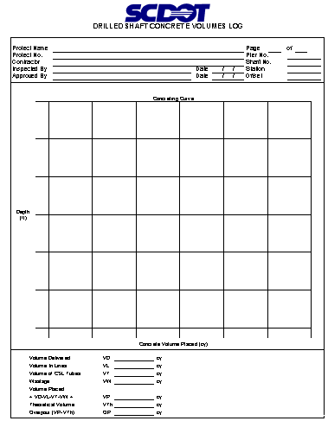
1

2

Top of Shaft
Bottom of Shaft
Trouble Territory!
Theoretical Line

Fill in every blank on the form. If it does not apply put an “N/A” or a long dash.

Use pencil – but never erase. If you need to change something, strike a single line through the item and insert the correct information above it. If there is insufficient room to make a note, footnote the item and go to the bottom of the page, or use a separate page.

1. | Heading: | -Fill in before drilling starts.
 |  | -Be sure to print your name and the start date of drilling.
 |  | -The Project Resident Engineer or designated representative will sign approval line.
2. | Concrete curve: | -compute Theoretical Volume of Concrete based on shaft size:
 |  | Vth =(πd² /4)x L
-locate points based on known cubic yards of concrete placed at measured “bottom”
depth.
 |  | -must be plotted during concrete placement.

Note: Plotted line should closely parallel Theoretical line.
There is a problem if:
- a point plots way above or below the Theoretical line and/or
- there is a significant rise or fall in an otherwise straight line (change in slope of line).

